Athens State MA331 Name____________________________
TEST Unit 1 and 2

Computational Problems:

18.
A highway patrol officer gave 34 speeding tickets last week on a stretch of highway having a 65mph speed limit. The speeds recorded for the 34 tickets are listed below.

92 78 79 79 77 88 76 71 81 92 86 73 82 87 75 70 76 72 79 84 79 87 76 76 92 75 87 90 72 77 85 90 89 89

Construct a stem-and-leaf display of the data.

19. Use the following data for test grades on an Algebra II exam.

100 88 74 65 99 93 56 42 28 56 95 88 66 72 73
72 86 69 85 72 95 94 95 52 56 87 76 95 84 80
86 42 92 90 83 77 95 51 93 74 88 32 21 99

Frequency Table (6 classes)

Class  Interval | Upper and Lower  Bounds | Frequency | Relative Frequency | Cumulative  Relative  Frequency
 | Totals

20 Using the frequency table below, draw and label an Ogive to the right of it.

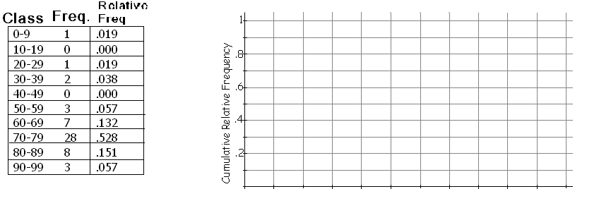

21 An insurance agent is interested in the amount of money paid out in claims involving fire damage. A sample of 20 claims were selected and the amount of fire damage for each claim is listed below in thousands of dollars.

52 59 32 54 45 73 39 62 97 65 58 48 62 28 30 69 13 41 75 36

h.) list the 5 number summary

i.) Draw the modified boxplot for the given data.

22. Below is a frequency Chart of the exam grades for exam 1 in Mrs. Dupree’s BJHS AP Stats class. Draw and label a Frequency Histogram (4 pts)
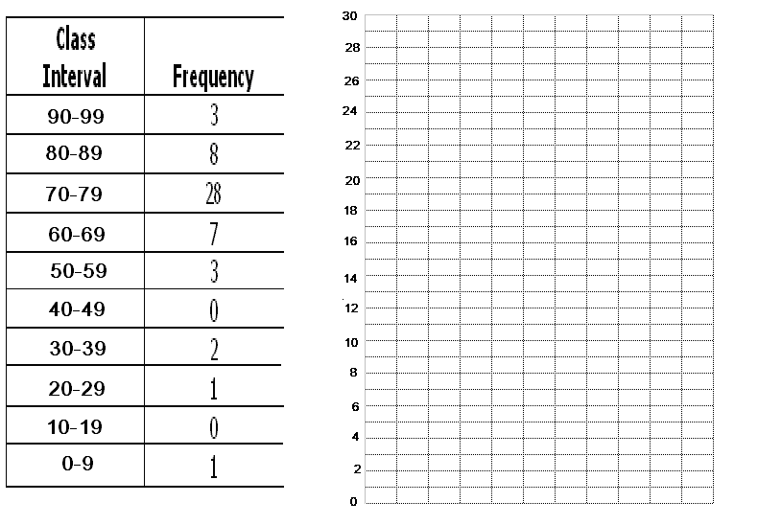23 The Montana Highway Patrol is studying the speed of automobiles on interstate highways in Montana. A large sample of car speeds was collected using radar and is summarized in the boxplot below.

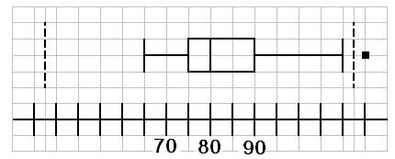

a.) Determine the lower quartile, sample median, and upper quartile from the boxplot.

- Determine the sample interquartile range from the boxplot.

- Would a speed of 105 be considered an outlier based upon the information contained in the above boxplot.

24. The average time Seth spends reading books for his AR goal is 40 min. and the standard deviation is 10 min.

- What value is one standard deviation above the mean?.

- What value is one standard deviation below the mean?

- What value is two standard deviations above the mean?

- What value is two standard deviations below the mean?

*e) what percentage of the times are between 20 and 60 minutes?

25

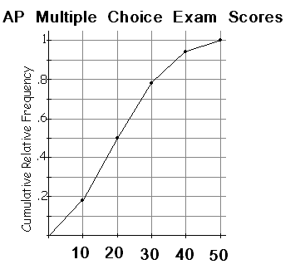

a. What AP Stats score is at the 20th percentile?

b. What SP Stats score is at the 90th percentile?

c. What is the median AP Stats score?

d. What is the IQR for the distribution of AP Stats scores?

e. About what percent scored above a 40?

